Easy Read – Planning with you
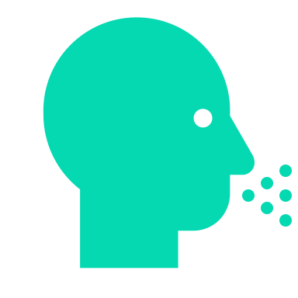 | Your voice is the essential
 | Please tell us about your needs and requirements.
 | Your Support Plan is designed with you at the centre of all actions.
 | Our staff will look at your current NDIS Plan funding to ensure that we have the services you need.
 | To create your plan, we may need to talk to your family, health providers and others (with your permission)
 | We will consult with you about many supports such as:  - Living skill development  - Your interests, leisure and community group involvement  - Travelling and transport needs
   | We will consult about:  - Family relationships  - Cultural requirements, e.g. food,  - Spiritual Identity – religious needs  - Communication methods
 | Your safety is checked:  - Physical environment  - Personal emergency plan
   | Your health needs are assessed:  - Medical needs  - General health requirements  - High-intensity requirements  - Allied health services  - Comprehensive health  - Vaccination support  - Oral health
 | We look for risks so we can get rid of or reduce them
 | We will create risk strategies and train our staff in these
 | Your Support Plan is reviewed every year
 | If your needs change, then we will review your plan earlier
 | You will need to sign your Support Plan
 | We will provide you with a copy of the Support Plan

