Easy Read – Risk Assessment
 | Your safety is essential to your support
 | Assessing risks to you will occur regularly.  Your risk assessment starts at your initial intake, then at least annually.
 | When your situation changes, we will undertake another risk assessment.
 | A risk is when it is probable that a specific event or activity may lead to you or someone else being hurt.
 | We assess risks by asking:  - What could go wrong?  - How often?  - How bad?  - Is there action needed?
 | A strategy will be written for any risk and recorded in your Support Plan.
 | We will discuss your risks and their strategies with you.
 | If we think an activity has high real or potential risk. We will talk to you about the risks. You can agree to undertake this activity (Informed-Consent)
  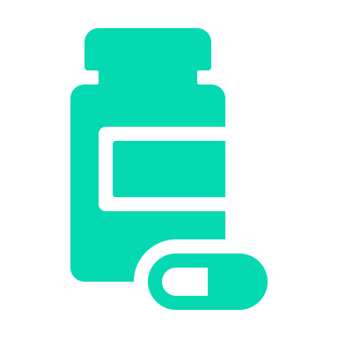 | Your environment is checked for:  - Trips and falls  - Electrical issues – cords  - Hot water temperature  - Medication storage  - Pets  - Physical environment – stairs etc

 | Your emotional environment is checked to ensure the people around you are supportive and not hurting you.
 | We look for risks so we can get rid of or reduce them
 | We will create and train staff in your risk strategies
 | If your needs change, then we will review your risks earlier

